**Connectivity Analysis Software for Estimating Linkage Priority**

**A User Guide and Tutorial for the**

**Linkage Priority Tool of the Linkage Mapper Toolbox**

*Version 3.0 —Updated July 2020*

**Software Requirements and Licensing**

**Want a quick start?**

**Run tutorial in section 10.1**

**and refer to section 1.1**

Linkage Priority tool requires **ArcGIS Desktop** (10.3 or greater) or **ArcGIS Pro** with the **ArcGIS Spatial Analyst** extension. More details can be found on the Linkage Mapper GitHub repository, where the code is hosted: <https://github.com/linkagescape/linkage-mapper>. Community support is available via the Google Groups forum: <https://groups.google.com/g/linkage-mapper>.

**Preferred Citation[1]**

Gallo, J. A., & R. Greene. 2018. Connectivity Analysis Software for Estimating Linkage Priority. Conservation Biology Institute, OR <https://doi.org/10.6084/m9.figshare.5673715>

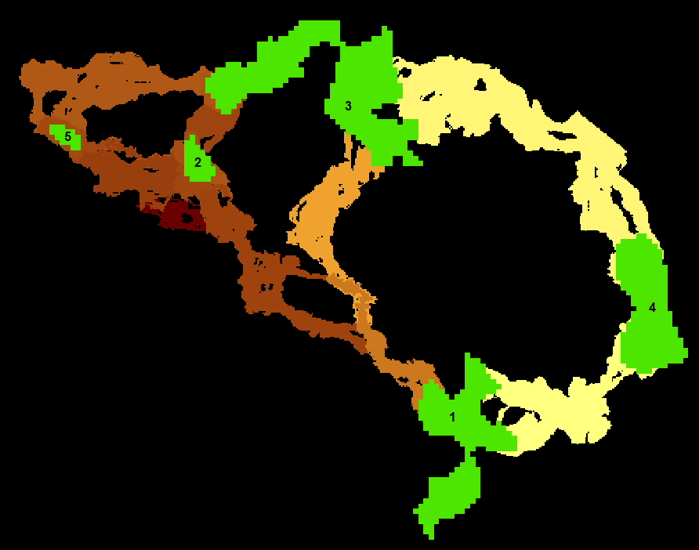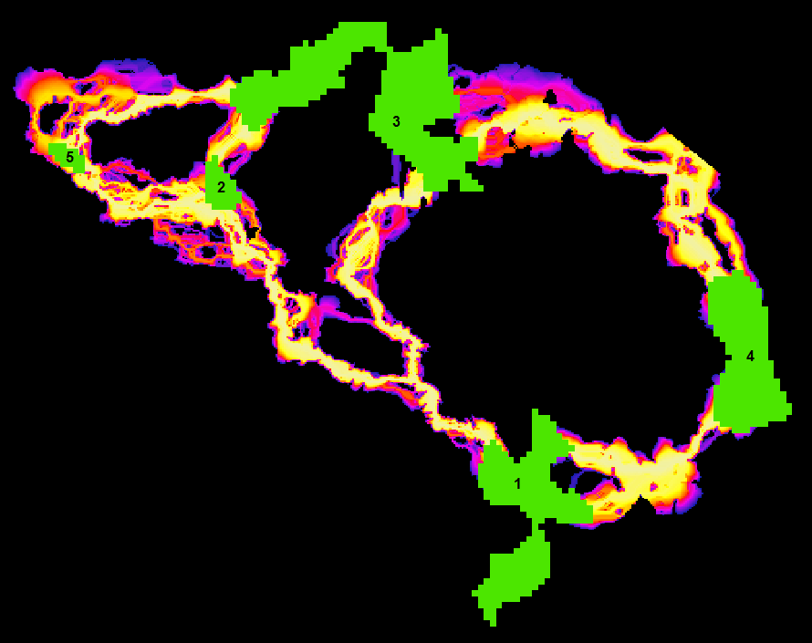

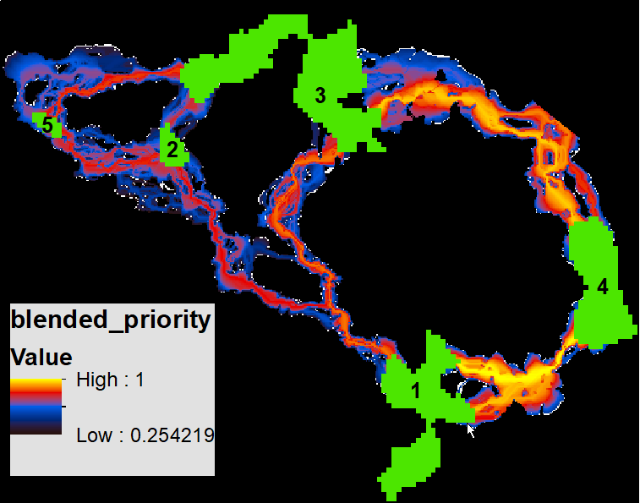**Table of Contents**

1 Introduction 3

1.1 Tool Overview 3

1.2 Climate-wise Considerations (optional) 4

1.3 Example Applications 4

2 Acknowledgements 4

3 Installation 5

4 Using Linkage Priority 5

4.1 Required Inputs 8

4.2 Core Area Value (CAV) Options 8

4.3 Corridor Specific Priority (CSP) Options 8

4.4 Blended Priority Options 10

4.5 Additional Options 10

4.6 Advanced Settings in lp_settings.py 10

5 Summary of Algorithm 11

6 Other Usage Notes 11

6.1 Upgrading 11

6.2 Enhancing Analyses Using Optional Settings 11

6.3 Other Suggestions and Troubleshooting 12

6.4 Other Applications 12

7 Community 13

8 Key Acronyms 13

9 Select References 13

10 Linkage Priority Tutorial 14

10.1 Run Linkage Pathways, then Linkage Priority Tool with Defaults 14

10.2 Add Other Core Area Value (e.g. Climate Refugia) 18

10.3 Add Climate Signature and Climate Preference 20

10.4 Combine the above sections into a single model run. 31

11 Advanced Linkage Priority Tutorial 32

11.1 Shortcut for Multiple Runs 32

11.2 Add Centrality 33

11.3 Inspect Core Area Value Component Calculations 34

11.4 Export Corridor Importance Value 34

# Introduction

Linkage Priority (LP) is an ArcGIS tool that helps quantify the relative conservation priority of each linkage in a landscape.

LP is run after linkages are created using the Linkage Pathways (LM) tool of the Linkage Mapper Toolbox (McRae and Kavanagh 2011). (The implementation of this original Linkage Mapper tool is hereafter symbolized as “LM” in this version of the User Guide).

## Tool Overview

The Linkage Priority Tool is based on weighted combinations among many factors (see below Figure). The lower set of factors on the diagram estimate the relative priority of the two cores at either end of a linkage. These factors include the shape, mean resistance value, size, and expert opinion. An assumption is then made that a linkage which connects two really important core areas is a higher conservation priority than one that connects two marginal core areas. The Tool calculates this relative value for every linkage. This output is combined with the other higher level factors (top row) that relate directly to linkage priority, including the permeability of each linkage (i.e., the mean resistance values along the least cost path), the proximity, the centrality (i.e. how central the linkage is to the entire network), and an expert opinion option. The expert opinion option is implemented via a table of each linkage as a row, and a relative value of each linkage based on expert opinion, or other factors, such as demographic analyses.

**Figure: Diagram of all the optional criteria that can be used in determining the relative priority of each linkage**

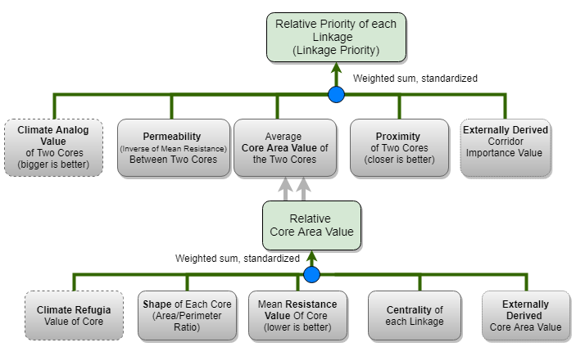

## Climate-wise Considerations (optional)

There are many climate considerations that can be incorporated in habitat connectivity modeling and mapping. Two have previously been pursued in isolation from each other, and yield quite different recommendations for linkage priority. However, we maintain that they are two extremes of the same continuum, and have updated this tool (in v3.0 compared to v2.0) so the user can model for one, or the other, or an appropriate blend between both (which we recommend). The first consideration is “range shift connectivity”, and gives higher priority for linkages that connect core areas that will become too hot/dry in the future with cores that are much cooler/wetter, allowing species to “move to higher ground” (Keeley et al. 2018). Meanwhile, “climate analog connectivity” gives higher priority to linkages with the destination core having the same predicted climate at a future time (e.g. 2050), as the climate in the source core at the current time (e.g. Littlefield et al. 2017). Each approach is better than nothing, but each has its opposing questionable assumptions. In addition to being able to model for a balance between these assumptions, we also added “preferred climate” as a factor in defining linkage priority. If this parameter is used, then linkages that end in a core area that is predicted to be near the preferred climate are given higher priority than linkages that lead to core areas predicted to be much hotter/drier than the preferred climate. More details are provided in the “white paper / specifications document” (Gallo, 2019). This criterion, on the top row of the diagram, is optional. Users can also include climate in determine relative core area value, by giving higher value to cores with higher amount of climate refugia. This criterion, on the bottom row of the diagram, is also optional.

See the section 10.3 “Using Linkage Priority/Add Climate Signature” for more details.

## Example Applications

Prototype applications of various beta versions of the Linkage Priority Tool have been performed in six regions (Sierra Nevada mountains, Sonoma County, Santa Barbara County, West Mojave, Sacramento Valley, and Modoc Plateau), with outputs available on a [databasin.org Gallery](https://databasin.org/galleries/027492e42545494cae53ca1f61b46c17) and reports (Spencer et al. 2019; Gallo et al. 2019). Climate was considered in ways in determining priority: (1) quantifying which linkages best facilitated long-term species range shifts, (2) which core areas had more stable climate over time and hence provided refuge from climate change, and (3) which core areas contained more climate micro-refugia for withstanding climate change.

# Acknowledgements

The first iteration of the Linkage Priority Tool was developed thanks to funding from a South Africa National Research Foundation post-doctoral research grant (#47264) through Nelson Mandela Metropolitan University. We would like to thank the additional organizations that have funded this work in various co-production applications: Sonoma County Agricultural Preservation and Open Space District, The Wilderness Society, California Department of Fish in Game via Dr. Megan Jennings, Charlotte Martin Foundation, and Conservation Biology Institute.

Thanks also to Darren Kavanagh, Annie Prisbrey, Nik Stevenson-Molner, Tim Sheehan, Nathaniel Mills, and Justin Brice for their advice and their participation in the updates and/or releases of LP.

In caring memory of Brad McRae, the founding developer of Linkage Mapper toolbox. “Everyone who knew Brad was impressed with his intelligence, thoughtfulness, integrity, honesty, and his steadfast commitment to what he cared about: his family, friends and conserving the natural world.”[2]

# Installation

Download Linkage Mapper v3.0 or greater from <https://circuitscape.org/linkagemapper> and first follow the installation instructions of the Linkage Pathways User Guide. You can test your installation by running the tutorial at the end of this document.

# Using Linkage Priority

The key factors of LP’s multi-criteria analysis are summarized above in the introduction.

The weights for these, and the associated parameters, are accessed through the ArcGIS toolbox tool. LP is run after understanding and running LM, and optionally after Centrality Mapper. Open LP from the Linkage Mapper toolbox.

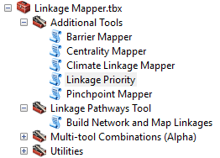

The following tool dialog should appear:

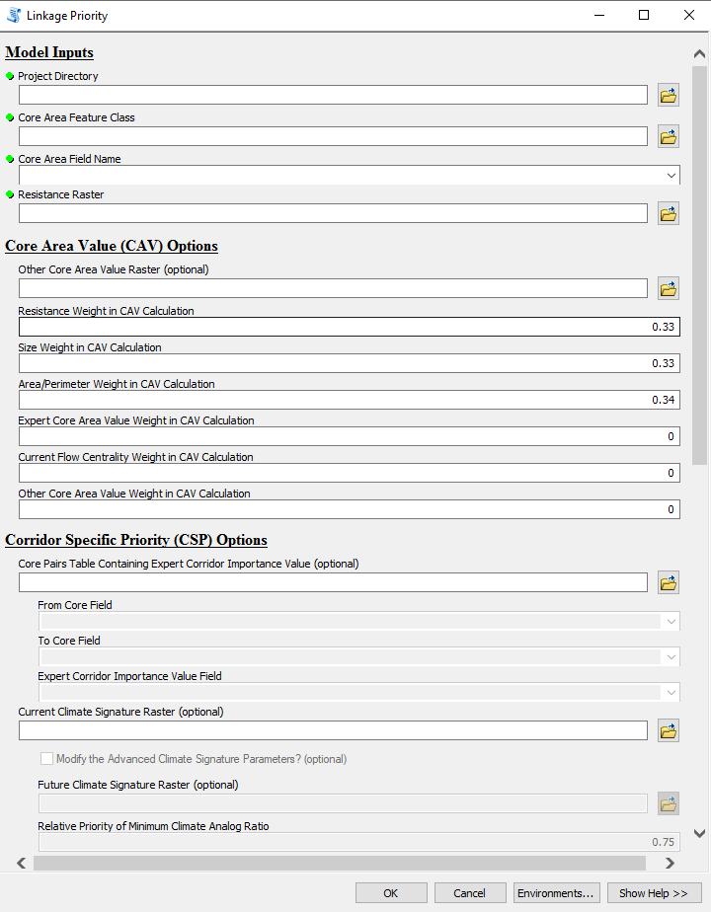

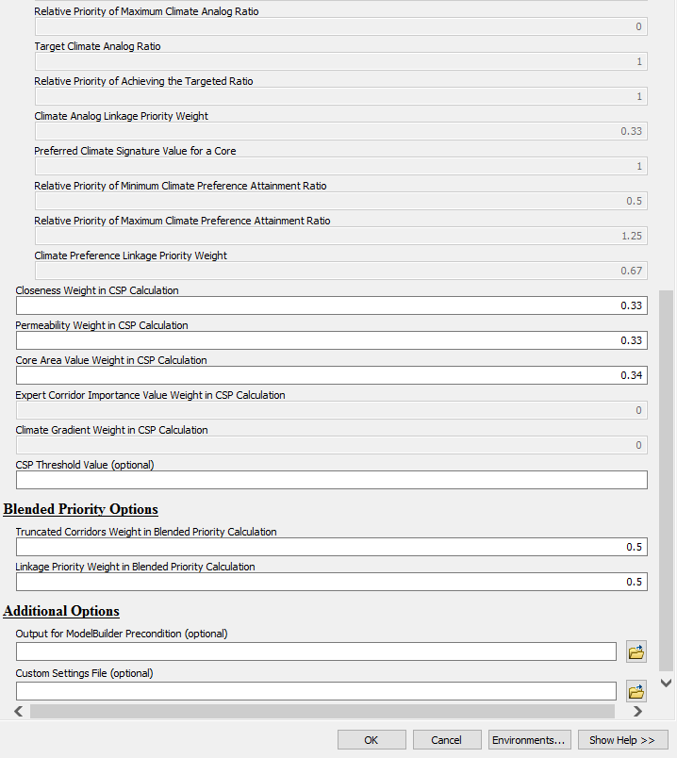

Descriptions for the required and optional tool parameters follow. They are also available in the tool dialog by selecting a parameter and clicking Show Help >>, for example:

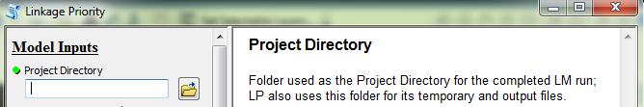

For additional details, please see section 6 Other Usage Notes later in this document.

## Required Inputs

* *Project Directory*: folder used as the Project Directory for the completed LM run; LP also uses this folder for its temporary and output files
* *Core Area Feature Class*: core habitat area polygons, used as the Core Area Feature Class for the completed LM run
* *Core Area Field Name*: field in the Core Area Feature Class containing a unique identifier for each core, used as the Core Area Field Name for the completed LM run
* *Resistance Raster*: cost raster, used as the Resistance Raster for the completed LM run

## Core Area Value (CAV) Options

* *Other Core Area Value (OCAV) Raster*: optional raster whose values within each core will be averaged to create the OCAV for that core
* Weighted sum weights (should sum to 1) to be used in the calculation of the CAV attribute:
  + *Resistance Weight*: decimal value between 0 and 1 to be multiplied by the normalized mean resistance for the core
  + *Size Weight*: decimal value between 0 and 1 to be multiplied by the normalized size of the core
  + *Area/Perimeter Weight*: decimal value between 0 and 1 to be multiplied by the normalized area/perimeter ratio of the core
  + *Expert Core Area Value (ECAV) Weight*: decimal value between 0 and 1 to be applied to the normalized optional ecav field, for storing an expert assessment of the relative value of each core; see sections 6.2 and 6.4 below for additional details
  + *Current Flow Centrality (CFC) Weight*: decimal value between 0 and 1 to be applied to the normalized CF_Central field, which is optionally calculated by Centrality Mapper after running LM but before running LP; see section 6.2 below for additional details
  + *Other Core Area Value (OCAV) Weight*: decimal value between 0 and 1 to be applied to the normalized ocav field, which is calculated from the optional OCAV raster; see section 6.2 below for additional details

## Corridor Specific Priority (CSP) Options

* *Core Pairs Table Containing Expert Corridor Importance Value (optional)*: a table, feature class or raster attribute table of the user’s choice containing an Expert Corridor Importance Value (ECIV) field that stores an expert assessment of the relative value of each corridor
  + *From Core Field*: field in the Core Pairs Table that stores the unique identifier for one of the cores in the pair.
    - *Note*: User may need to manually type in the Field Names rather than finding them as drop-down options
  + *To Core Field*: field in the Core Pairs Table that stores the unique identifier for the other core in the pair.
  + *Expert Corridor Importance Value Field*: field in the Core Pairs table that stores the expert assessment of the corridors.
* *Current Climate Signature Raster (optional)*: optional raster used to calculate the current climate signature (i.e. envelope) for each core, which feeds into the climate signature difference calculation for the two cores at the end of each corridor; see section 6.2 below for additional details.
  + *Modify the Advanced Climate Signature Parameters? (optional)* If this is checked, then the below parameters will turn from grey to black. If left unchecked, then the analysis will move forward with the assumption that the relative difference in climate between cores is much higher than the relative difference in climate at a core between time steps. Hence, the Current Climate Signature Raster will be used as a surrogate for the Future Climate Signature Raster, and all the below default parameter values will be used.
  + *Future Climate Signature Raster*: An optional raster used to calculate the future climate signature (i.e. envelope) for each core, which feeds into the climate signature difference calculation for the two cores at the end of each corridor; see section 6.2 below for additional details
  + *Relative Priority of Minimum Climate Analog Ratio* This is ARmin , which is subjective. It is the Climate Analog Linkage Priority Value (A) of the core pair on the landscape that has the lowest Climate Analog Ratio (R) , which is  /  , (i.e. the climate value of the destination core (D) at the future time step, T, divided by the climate value of the starting (hotter) core at the present time, T = 0.)
  + *Relative Priority of Maximum Climate Analog Ratio* This is ARmax , which is subjective. It is the Climate Analog Linkage Priority Value (A) of the core pair on the landscape that has the highest Climate Analog Ratio (R) , which is  /  , (i.e. the climate value of the destination core (D) at the future time step, T, divided by the climate value of the starting (hotter) core at the present time, T = 0.)
  + *Target Climate Analog Ratio* The targeted value of R, Rtargeted, that is the value on the X axis of the chart in the white paper that is the inflection point on the curve between Rmin  and Rmax . For all but the most extreme edge cases, this is going to be the R that is the highest linkage priority value.
  + *Relative Priority of Achieving the Targeted Ratio* The value of A (on the Y-axis of the chart in the white paper) that corresponds with Rtargeted  on the graph. This value of A is referred to as ARtargeted .
  + *Climate Analog Linkage Priority Weight* This is the relative weight of the Climate Analog Linkage Priority (A) of a linkage compared to the Climate Preference Linkage Priority Weight. These two weights should add to 1. The default value is 0.67 for now since this is a more established concept than Climate Preference and is also arguably more important.
  + *Preferred Climate Signature Value for a Core* At future time T, what is the preferred climate value of a core area? An initial approach to determining this value would be to look at a map of climate signature at the current time, and to look at the climate signature values of the places that currently have a preferred climate for the species and/or ecological processes that are being targeted. In other words, just because a linkage has a great climate analog match, does not mean it is a perfect climate-wise linkage. If it is matching a relatively hot/dry core to a core that is also relatively hot/dry in the future, it is not as good as if it were matching a cool/wet core to a core that is cool/wet in the future.
  + *Relative Priority of Minimum Climate Preference Attainment Ratio* This is LGmin , which is subjective. It is the Relative Priority of the Linkage’s Climate Preference Attainment Ratio (L) of the core pair on the landscape that has the lowest Climate Preference Attainment Ratio (G).
  + *Relative Priority of Maximum Climate Preference Attainment Ratio* This is LGmax , which is subjective. It is the Relative Priority of the Linkage’s Climate Preference Attainment Ratio (L) of the core pair on the landscape that has the highest Climate Preference Attainment Ratio (G).
  + *Climate Preference Linkage Priority Weight* This is the relative weight of the Climate Preference Linkage Priority (L) of a linkage compared to the Climate Analog Linkage Priority Weight (A). These two weights should add to 1. The default value is 0.33 for now since this is a less established concept than Climate Analog value, and would also likely be deemed less important in most expert workshops.
* CSP weighted sum weights (should sum to 1) used to create a CSP raster for each corridor:
  + *Closeness Weight*: decimal value between 0 and 1 to be multiplied by the normalized distance between the two cores of the corridor
  + *Permeability Weight*: decimal value between 0 and 1 to be multiplied by the normalized permeability (inverse of the average resistance) of the corridor
  + *Core Area Value Weight*: decimal value between 0 and 1 to be multiplied by the normalized average CAV of the two cores of the corridor
  + *Expert Corridor Importance Value Weight*: decimal value between 0 and 1 to be multiplied by the normalized ECIV of the corridor
  + *Climate Gradient Weight in CSP Calculation*: decimal value between 0 and 1 to be multiplied by the weighted sum between climate preference priority value and climate analog linkage priority
* *CSP Threshold Value:* The threshold value for normalized Corridor Specific Priority linkages below which the linkages will not be mapped. Filters out poor quality linkages and insures that the blended map will only contain high quality linkages.

## Blended Priority Options

* Blended Priority weighted sum weights (should sum to 1) used to create the blended_priority output raster:
  + *Truncated Corridors Weight*: weight to be multiplied by the truncated least cost corridors output (e.g. project_corridors_truncated_at_200k )
  + *Linkage Priority Weight*: weight to be multiplied by the each linkage’s linkage_priority raster in memory.

## Additional Options

* *Output for ModelBuilder Precondition*: optional output copy of the input cores, which can be used in ModelBuilder workflows to indicate that LP has finished processing
* *Custom Settings File*: optional .py file to be used in place of lp_settings.py, which facilitates keeping all the settings needed to reproduce a scenario run. (See below section).

## Advanced Settings in lp_settings.py

The following settings will not normally need to be changed, and can only be changed by editing lp_settings.py (in toolbox/scripts).

* RELPERMNORMETH (number): relative permeability normalization method (use 0 for score range normalization; any other value for maximum value normalization)
* RELCLOSENORMETH (number): relative closeness value normalization method (use 0 for score range normalization; any other value for maximum value normalization)
* CALCLP (Boolean): calculate linkage priority
* NORMCORRNORMETH (number): normalized corridor normalization method (use 0 for score range normalization; any other value for maximum value normalization)
* RESNORMETH (number): resistance normalization method (use 0 for score range normalization; any other value for maximum value normalization)
* SIZENORMETH (number): size normalization method (use 0 for score range normalization; any other value for maximum value normalization)
* APNORMETH (number): area/perimeter ratio normalization method (use 0 for score range normalization; any other value for maximum value normalization)
* ECAVNORMETH (number): ecav normalization method (use 0 for score range normalization; any other value for maximum value normalization)
* CFCNORMETH (number): cfc normalization method (use 0 for score range normalization; any other value for maximum value normalization)
* NORMALIZERCI (Boolean): normalize RCI
* TRUNCNORMETH (number): truncated raster normalization method (use 0 for score range normalization; any other value for maximum value normalization)
* CALCBP (Boolean): calculate blended priority (requires CALCLP above to also be True)
* NORMALIZELP (Boolean): normalize Linkage Priority
* NORMALIZEBP (Boolean): normalize Blended Priority
* KEEPINTERMEDIATE (Boolean): keep intermediate outputs for troubleshooting purposes
* MAXCSPWEIGHT (Boolean): relative max CSP value weight in CPV calculation
* MEANCSPWEIGHT (Boolean): relative mean CSP value weight in CPV calculation

# Summary of Algorithm

* + This section of the document has been deprecated between version 2.0 and version 3.0
  + The slightly updated version 2.0 algorithm summary is [here](https://docs.google.com/document/d/1_NKZnXJ5ficCY60J4thxQtux27Z1yh3FTT2ZYS-TlQ0/edit).
    - If anyone wants to volunteer to update it to version 3.0 summary that would be appreciated.

# Other Usage Notes

## Upgrading

For those upgrading to version 3.0 from earlier versions of LM, please consider the following:

* If you want your old projects to automatically use the new LM and LP, install the toolbox in the same location as the previous version.
* Due to the addition of new LM parameters in the LM tool dialog, running LM from geoprocessing results history will result in “ERROR 000820 The parameters need repair”. To overcome this issue, run LM from the toolbox, not from the geoprocessing history.
* ModelBuilder models that use LM will need to be edited, re-validated and saved.

## Enhancing Analyses Using Optional Settings

LP’s optional settings can be used in a variety of ways. Some suggestions are provided here:

* Climate change analyses can be incorporated into linkage prioritization in at least two ways:
  + By providing an Other Core Area Value raster, such as a refugia dataset, that reflects the relative importance of different areas of the landscape in providing resilience to climate change.
    - This will impact the Core Area Value, which is a component of Corridor Priority Value.
    - See the Linkage Priority Tutorial below for an example.
  + By providing Current, and optionally Future, Climate Signature datasets, which allow a Climate Signature Difference to be calculated for each corridor.
    - See the Linkage Priority Tutorial below for an example.
* Expert input can be incorporated in at least two ways:
  + By adding an Expert Core Area Value field (must be name “ecav”) to the Cores polygon input dataset. This will impact the Core Area Value, which is a component of Corridor Priority Value.
  + By providing a table of core pairs, with an Expert Corridor Importance Value (ECIV) field (can be any name). ECIV is an optional component of Corridor Priority Value.
* Centrality is a measure of how important a link or core area is for keeping the overall network connected. If run, Centrality Mapper will create a field in the Cores polygon dataset called CF_Central. Providing a Current Flow Centrality Weight will normalize CF_Central and include it in the Core Area Value calculation.

## Other Suggestions and Troubleshooting

* When creating a field to store expert values for ECIV for each corridor, project_LCPs is not a good place to do this because it gets overwritten on every run of the LM tools. One option is to make a copy of this feature class in another location and use it.
* If you encounter an error along the lines of “ERROR 010423: project_RCI.RASTER.1(Band_1) does not have valid statistics as required by the operation” when calculating overall linkage priority, it could be that the setting used for Proportion of Top CSP Values to Keep resulted in an empty Corridor Specific Priority for one or more corridors, and therefore an empty RCI raster. Try a larger value for the Proportion of Top CSP Values to Keep setting.
* If you move the project directory structure and files to another location after LM has been run (not advised), please note that:
  + LM must be re-run before LP can be run, because the LM environment has been picked up from the run history and contains the old path.
  + You cannot re-run the LM family of tools from the geoprocessing history because the location of the tools will have changed.
  + Also, you cannot rename a LM Project folder, even keeping it in place, and expect LP to run on that folder.

## Other Applications

LP came about primarily to facilitate embedding of linkage analysis in iterative geoprocessing routines such as Land Advisor models (Aplet et al. 2016, Gallo et al. In Prep). Land Advisor evaluates a landscape for conservation priorities, uses a greedy heuristic to assume the highest priority area is conserved, and then repeats the process to identify the second-highest priority area. Embedding LM/LP allows Land Advisor to extend its scope from prioritization of core protected areas to include prioritization of corridors among them.

Of course, LP can also be used in standalone corridor identification projects that require prioritization of conservation action among potential corridor areas. Doing such an analysis draws from a rich field of theory and practice. Perhaps the best repository of such information is <https://conservationcorridor.org/library/> and the best practical guide for getting up to speed on the practice of resistance-surface based connectivity modeling is by Wade et al. (2015).

# Community

Please join the Linkage Mapper User Group to get updates, report bugs, and suggest enhancements (<https://groups.google.com/forum/#!forum/linkage-mapper>).

We also encourage contributions to the LM project by ArcGIS/Python developers. This could include enhancements and fixes to existing tools, and development of new tools for the LM toolbox. We encourage new tools to follow the protocols in Linkage Priority and Climate Linkage Mapper, which are currently the two newest tools in the LM toolbox. The source code repository is at <https://github.com/linkagescape> . We welcome any comments and suggested edits to the latest version of this and other user guides available in the repository as Word documents.

# Key Acronyms

* CAV = Core Area Value
* CFC = Current Flow Centrality
* CPV = Corridor Priority Value
* CSP = Corridor Specific Priority
* CW = Cost Weighted
* CWD = Cost Weighted Distance
* ECAV = Expert Core Area Value
* ECIV = Expert Corridor Importance Value
* LCP = Least Cost Path
* LP = Linkage Priority
* LM = Linkage Mapper
* OCAV = Other Core Area Value
* RCI = Relative Corridor Importance

# Select References

Aplet, G, P. McKinley, and J. Gallo. 2016. Keynote Presentation: Spreading Conservation Risk with a Portfolio of Strategies. Natural Areas Association. Sacramento, CA Oct. [[video](http://cdnapi.kaltura.com/index.php/extwidget/preview/partner_id/1770401/uiconf_id/28589212/entry_id/0_je7bsg2d/embed/dynamic)]

Gallo, J., G. Aplet, F. Davis, R. Greene, M. Lombard, and J. Thomson. In Prep. A new framework of spatial allocation modeling for multiple objectives that emphasizes transparency and includes climate-wise connectivity.

Gallo, JA., ​2019. ​Software for prioritizing habitat linkages based on climate gradients, climate analogs, or a balanced blend. ​<https://doi.org/10.6084/m9.figshare.7689080>

[Gallo, John A., J. Strittholt, G. Joseph, H. Rustigian-Romsos, R. Degagne, J. Brice, and A. Prisbrey. 2019. “Mapping Habitat Connectivity Priority Areas That Are Climate-Wise and Multi-Scale, for Three Regions of California.” Conservation Biology Institute. https://doi.org/](http://paperpile.com/b/MWVp9b/iSz3)[10.6084/m9.figshare.7477532](http://dx.doi.org/10.6084/m9.figshare.7477532)[.](http://paperpile.com/b/MWVp9b/iSz3)

McRae BH, Kavanagh DM. 2011. Linkage Mapper Connectivity Analysis Software. The Nature Conservancy, Seattle, WA. Available from <http://www.circuitscape.org/linkagemapper.>

[Spencer, Wayne, Justin Brice, Deanne DiPietro, John Gallo, Michelle Reilly, and Heather Rusigian-Romsos. 2019. “Habitat Connectivity for Fishers and Martens in the Klamath Basin Region of California and Oregon.” Conservation Biology Institute. https://doi.org/](http://paperpile.com/b/MWVp9b/soQp)[10.6084/m9.figshare.8411909](http://dx.doi.org/10.6084/m9.figshare.8411909)[.](http://paperpile.com/b/MWVp9b/soQp)

Wade, Alisa A. McKelvey, Kevin S. Schwartz, Michael K. 2015. Resistance-surface-based wildlife conservation connectivity modeling: Summary of efforts in the United States and guide for practitioners. General Technical Report RMRS-GTR-333. U.S. Department of Agriculture, Forest Service, Rocky Mountain Research Station, Fort Collins, CO. Available from <http://www.fs.fed.us/rm/pubs/rmrs_gtr333.pdf>[.](http://paperpile.com/b/5VGlk6/Fcw8T)

# Linkage Priority Tutorial

## Run Linkage Pathways, then Linkage Priority Tool with Defaults

* Open “LP Demo.mxd”
* Use the ArcCatalog Window to make a folder within the demoProject folder called called v001
* Optional: examine the resistance surface and core areas and see if you can predict where the linkages will be modeled, and where they will be wide and narrow.
* Open ArcToolbox and run the **Build Network and Map Linkages** tool in “Linkage Pathways Tool” toolset of the “Linkage Mapper” Toolbox.
* Set v001 as the Project Directory, use cores, core_id, and resistance_modoc as per the Linkage Pathways Tutorial, and the default settings as well as clicking on “Truncate Corridors” (under Step 5). This will clip the width of the linkage to be 200,000 cost weighted distance units from the least cost path.
* The screengrab below is how your settings should look before you press run, if you have an ArcGIS Advanced license.
  + If you don’t have an ArcGIS Advanced license, you will also need to select modoc_distances_cores.txt (provided in the demoProject folder) as the Core Area Distances Text File. (See LM user guide for info on how to create such a file)

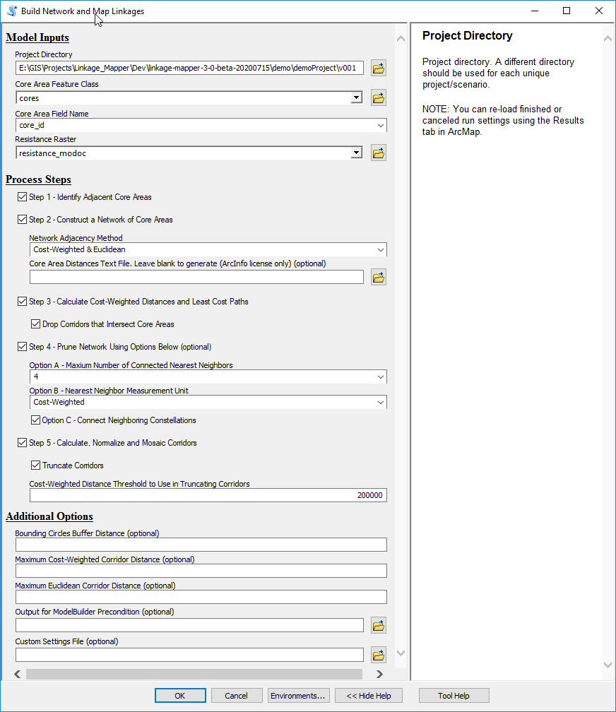

* Click **OK** to run the tool.
  + Optional: You have now made your linkages, please see if they met your expectations by adding them to the map: …demoProject\v001\output\corridors.gdb\v001_corridors_truncated_at_200k

It should look like: 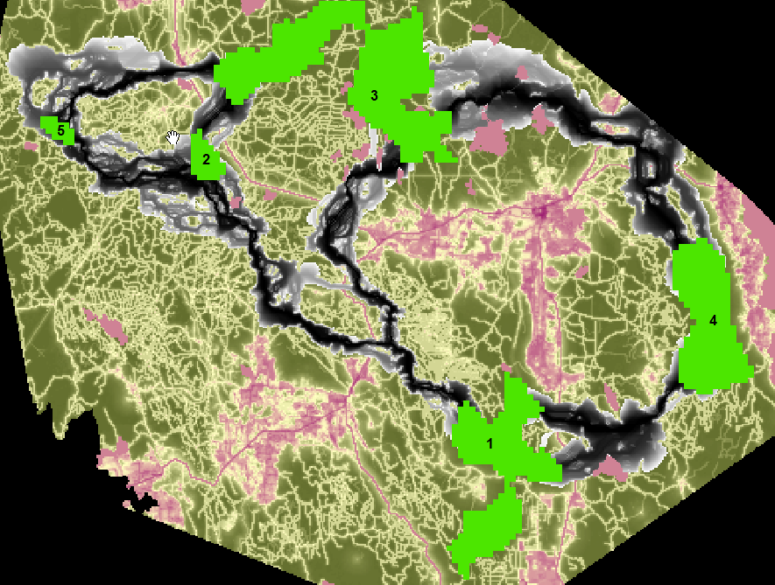

* + See the Linkage Pathways tutorial for more information on them.
  + Optional: click the cores and linkages on and off and think about how you would rank the linkages in order of importance.
* Then, open the **Linkage Priority tool** in the Additional Tools toolset, point to the same inputs, and use the default settings:

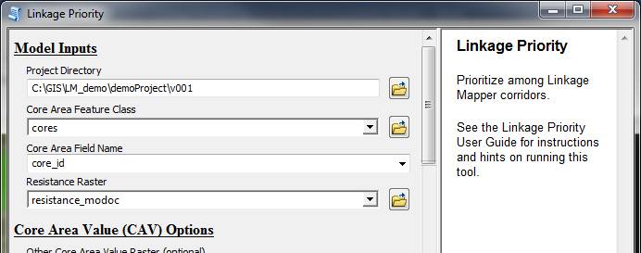

* Click **OK** to run the tool.
* After completion, add the dataset demoProject\v001\output\corridors.gdb\v001_linkage_priority to your map, and symbolize it with a Minimum-Maximum stretch.
  + *GIS tip: Click on Customize->Style Manager->Styles->“Add Style to List” then click on Linkage Mapper.style in toolbox\Styles folder* 
    - *Note the custom color ramps are at the bottom of your color ramps scroll bar*
* The output is referred to later as the “Default Run” and with the custom color combo (inverted) it should look like the following after you turn off the resistance surface:



* The output above shows that, based on default parameters, the most important linkage is between cores 1 and 4, closely followed by linkage 3-4. Default parameters: only using closeness, permeability, and core area value to determine linkage priority, and for core area value, only using average core resistance value, size, and area/perimeter weight; even weights.
* To save time, continue using the v001 directory, and move to the next section.
  + Optional: If you do not want to overwrite your previous run outputs,
    - Make a new folder called v002 and run **Build Network and Map Linkages** tool again, and then run Linkage Priority Tool with the changes below to the default values.
* Sometimes it is useful to see the priority value of each linkage mapped explicitly. To get this, change the weights of the blend, so that only Linkage Priority gets a weight:

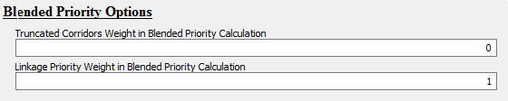

Yielding:

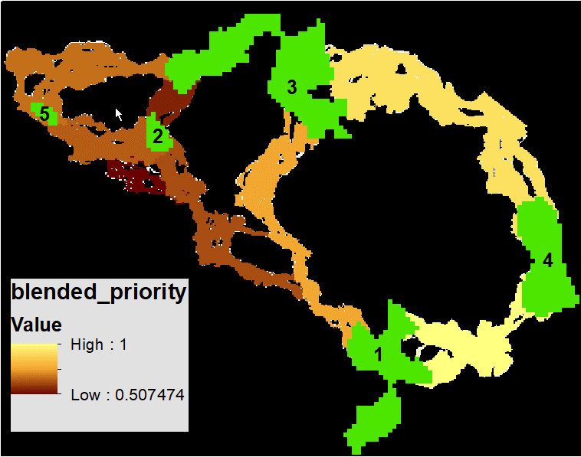

## Add Other Core Area Value (e.g. Climate Refugia)

In addition to the default considerations for Core Area Value, LP has an option to consider an additional raster input. This **Other Core Area Value** is averaged for each core area. It can be used for example, to give higher priority to corridors where the connected cores constitute important climate refugia areas. A dataset, climate_refugia_modoc has been provided in your .mxd to demonstrate this capability, it has higher values for areas of more stable climate and more topographic heterogeneity (from <https://databasin.org/datasets/d58de1a0b08443fea53c25b70804866c>).

* Optional: Take a moment to examine the layer, click on and off the core areas, and predict how it will change the results.

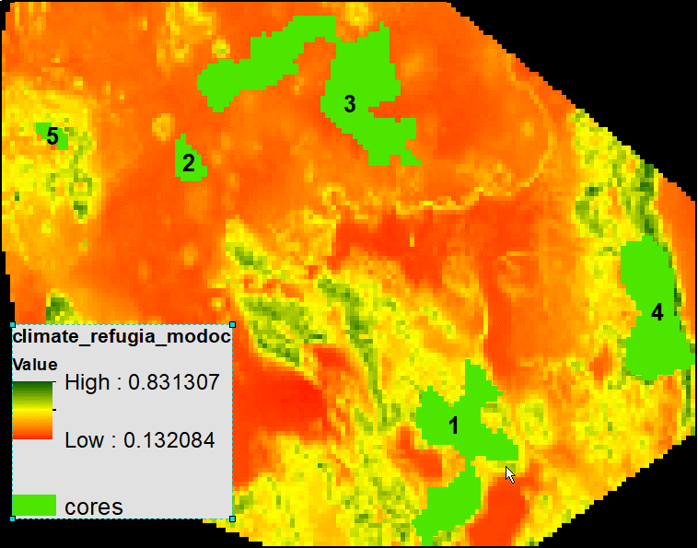

* Add it to the model run, as per the following, and use the following parameters to focus solely on the impact of this criterion.

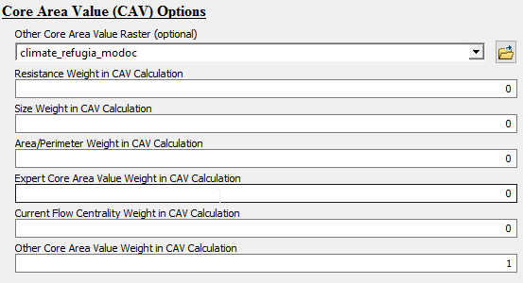

…

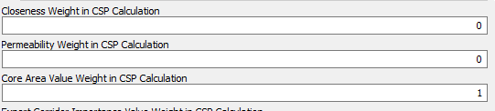

…

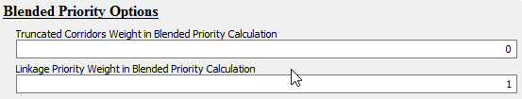

Yielding:

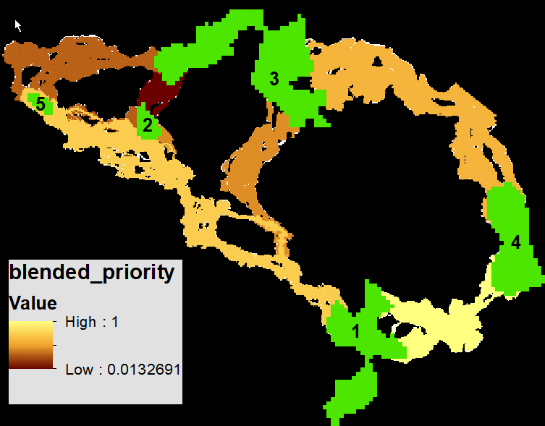

* Note how the relative importance of linkages 2-5 and 1-4 are now higher. This is because cores 4,1, and 5 have more micro-refugia, and hence a higher average refugia score, than the other cores.
* Pro-tip:
  + To see the relative climate refugia value per core area, open the cores attribute file and look at the “ocav” field. Higher value corresponds to more refugia.
  + To see the priority values as least cost paths, load link_maps.gdb/v001_LCPs and style CSP_Norm

## Add Climate Signature and Climate Preference

Another one of LP’s **optional features** for prioritizing corridors is **climate signature**. In version 3.0, this has been significantly improved compared to version 2.0. See section 1.2 “Climate-wise Options” for more details, and the draft white paper that it links to.

First, let’s examine the climate signature input layer climate_signature_current (below screengrab). (Climate Water Deficit, which has both temperature and precipitation in one metric: <https://databasin.org/datasets/dbd45814e4db43dea4472c3a3ccacd9b>.) The mean value of this layer for a core area is the climate signature of that core.

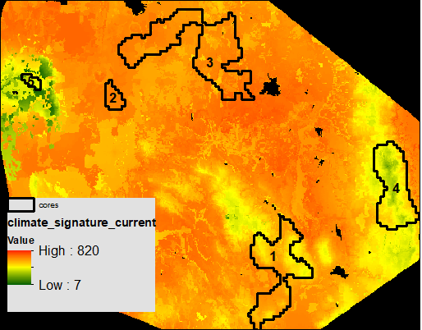

* Pro Tip: after a model run, the mean value per core is cores/cclim_env.
* There is a similar sample layer for the future climate projections (~2070-2099): <https://databasin.org/datasets/fd8adae0ab9149c0b200f11ab9e2d54b>

Let’s first model for range shift connectivity, that gives the highest priority to linkages that span a wide variance in climate signature, and let’s ignore climate preference for now:

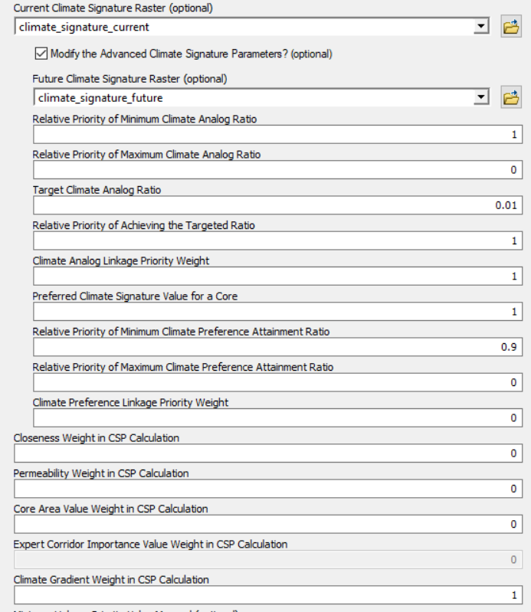

…

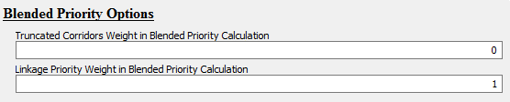

Yielding:

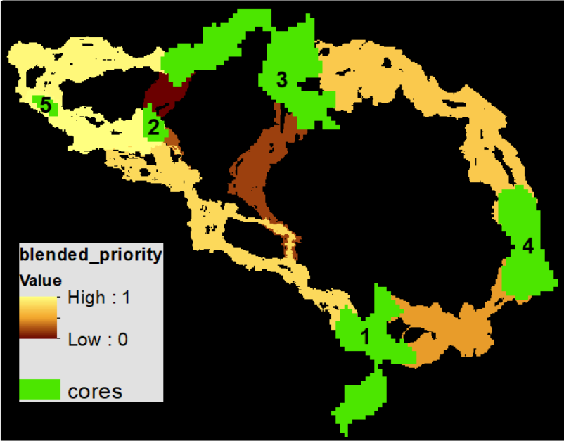

Note how the linkages of highest priority are from the hot/dry lowland cores (2, 3) to the coolest/wettest, higher elevation core (5).

Next, let’s use the typical algorithm in the literature for modeling climate analog connectivity: that the best linkages are those that connect a source core area with a destination core area, in which the destination’s climate in the future is like the source cores climate now. Typically, no distinction is made between if the destination core is hotter than the analog or cooler.

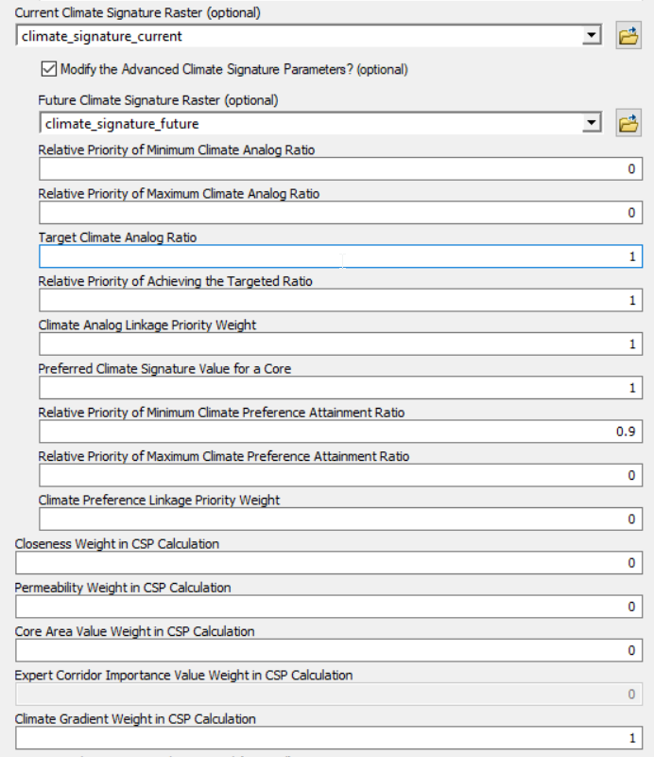

Yielding:

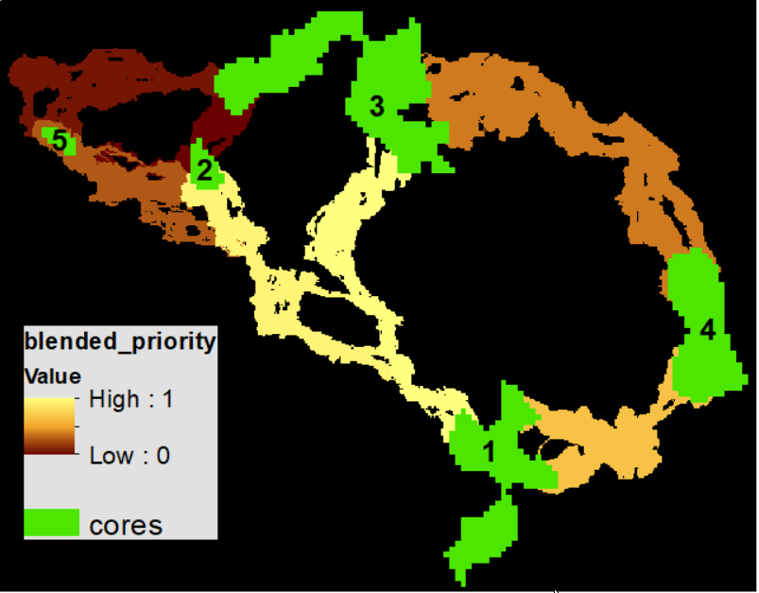

Note that linkages 2-5 and 3-5 are now very low priority.

Now let’s blend both of those considerations. A crude way to do this is like the following

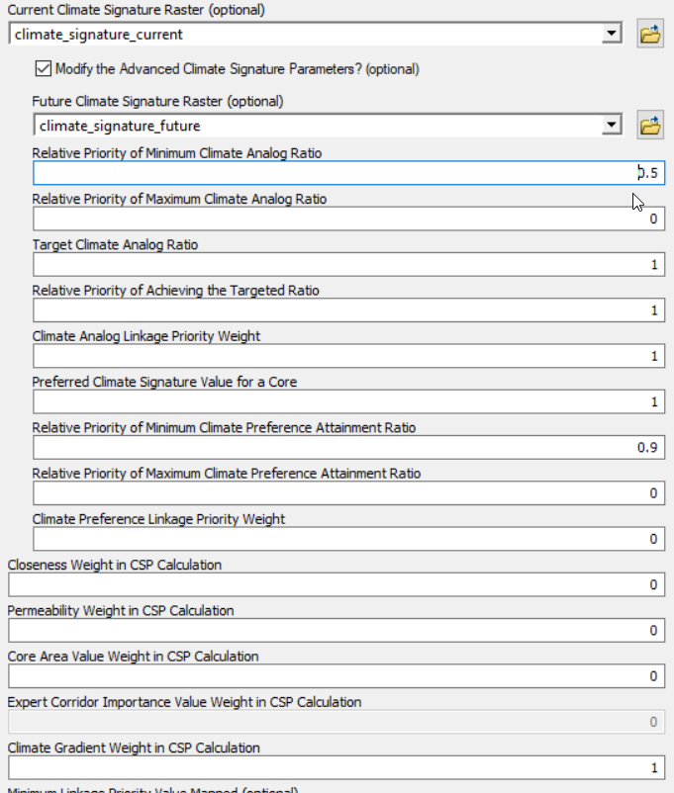

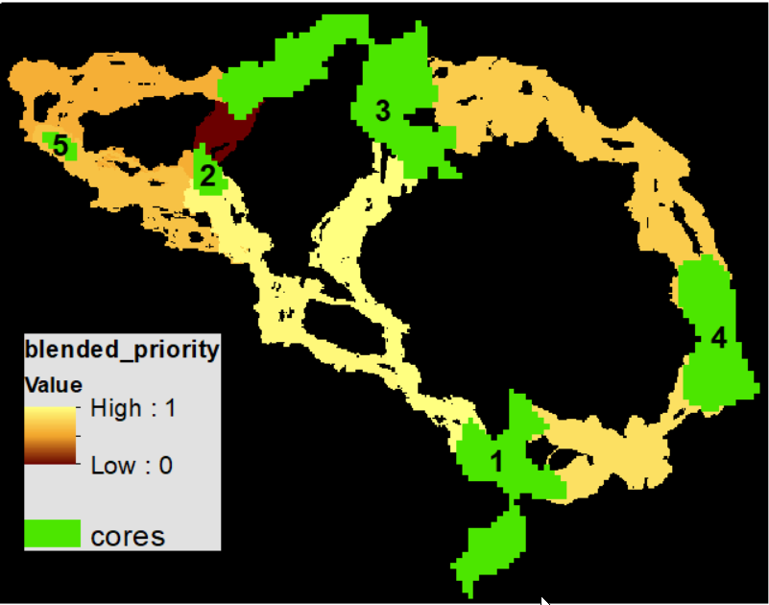

So, that is a big improvement, but it could be better. Currently, the model is not differentiating among linkages connectiong cooler cores (e.g. 1-4) versus ones connecting hotter cores (e.g. 3-1). Let’s assume that cooler/wetter is better, and that the preferred climate of a core is that of the second coolest core at the current time (Core 5, mean CWD = 329). And let’s give this fine tuning of climate preference a weight of 1 for now to see what it looks like if it were the only thing setting linkage priority:

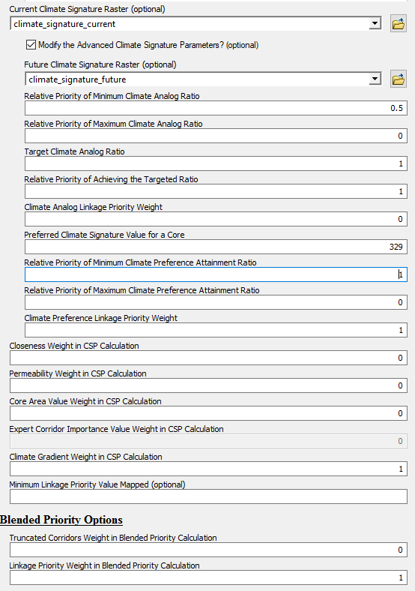

Yielding:

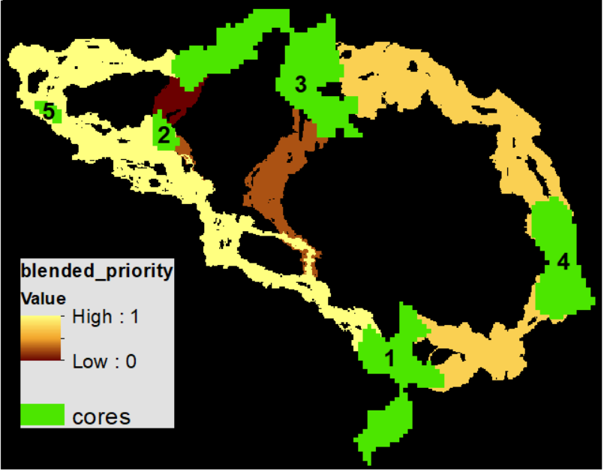As expected, all three linkages ending at core 5 have a value of 1. Now let’s blend this with the blended climate analog value, and give this fine tuning climate prefence factor a weight of 0.33 and the other 0.67.

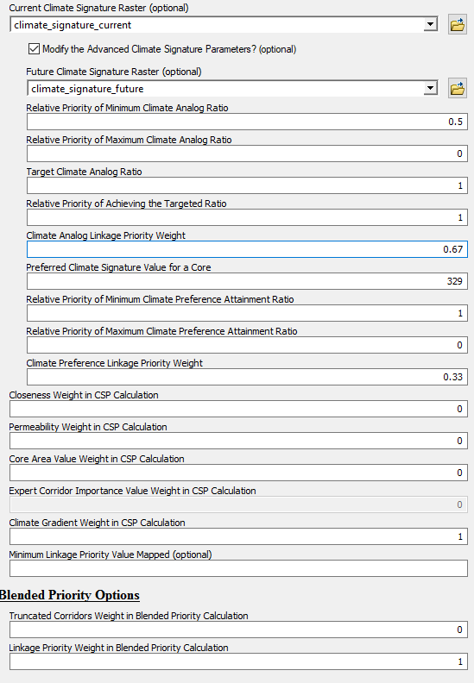

Yielding:

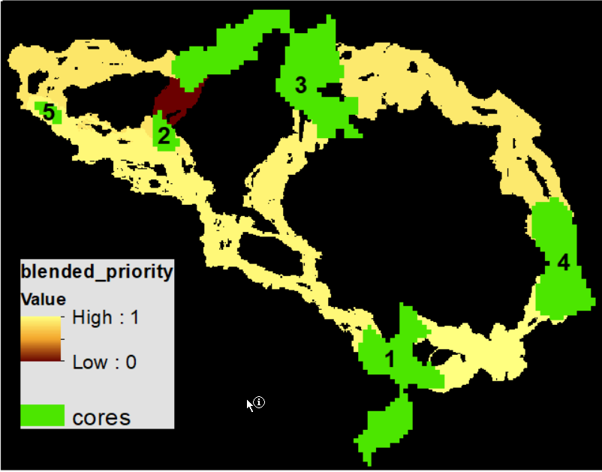

## Combine the above sections into a single model run.

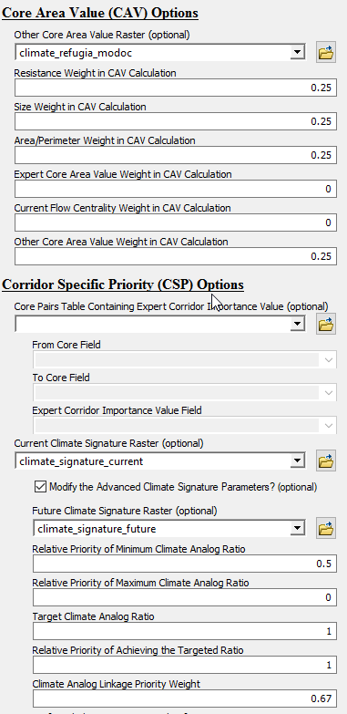

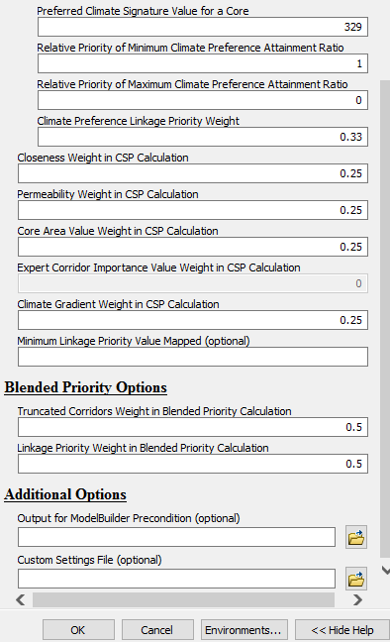

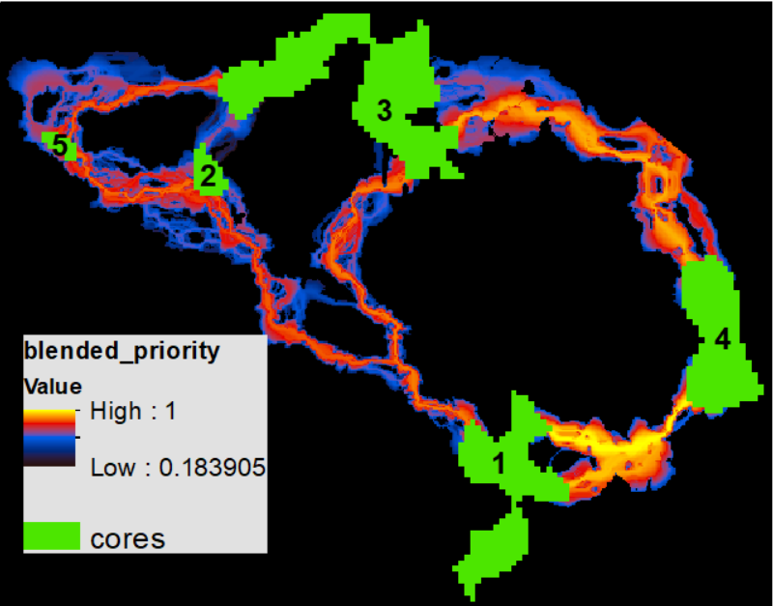

Now, with a much a higher degree of confidence, we can say that given the data we have, the criteria considered, and the even weights among them, that the linkage between cores 1 and 4 is the highest prirotity for investing resources, and the one between 2 and 3 the lowest priority.

# Advanced Linkage Priority Tutorial

## Shortcut for Multiple Runs

*The following is experimental, and a solid understanding of ModelBuilder is recommended. *

In most projects it is useful to run multiple iterations of the model to explore different parameters, and values, and to compare their outputs. So far, each iteration has been overwriting outputs in the v001 folder. The following discusses how to make and store multiple runs, and how to run both **Build Network and Map Linkages** as well as **Linkage Priority** tools at the same time, which is especially useful for huge landscapes, and running both at the same time.

Click “Edit” on one of these tools:

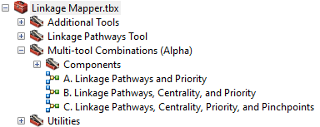

Change the “Project Directory” value to a new name. Run as much of the model as you can (the first step). Then validate the model. Then edit any parameter values as necessary. Save, and run the entire model.

## Add Centrality

Another one of LP’s **optional features** for prioritizing corridors is **core centrality**. This incorporates the outputs of Centrality Mapper as an input. See the Centrality Mapper user guide for more information on that tool. To use it here, run Centrality Mapper tool after running Build Network and Map Linkages, using the same Project Directory. Then, when using Linkage Priority, give Current Flow Centrality Weight in CAV Calculation a non-zero value, such as the following (remember, “best practice” is that all weights add to 1, so note that the Current Flow Centrality Weight has been adjusted):

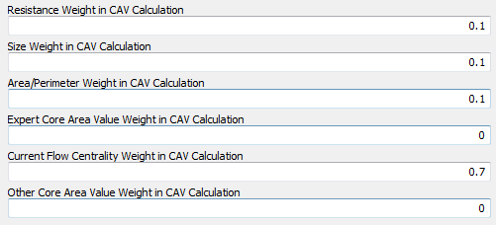

The result should look like the following:

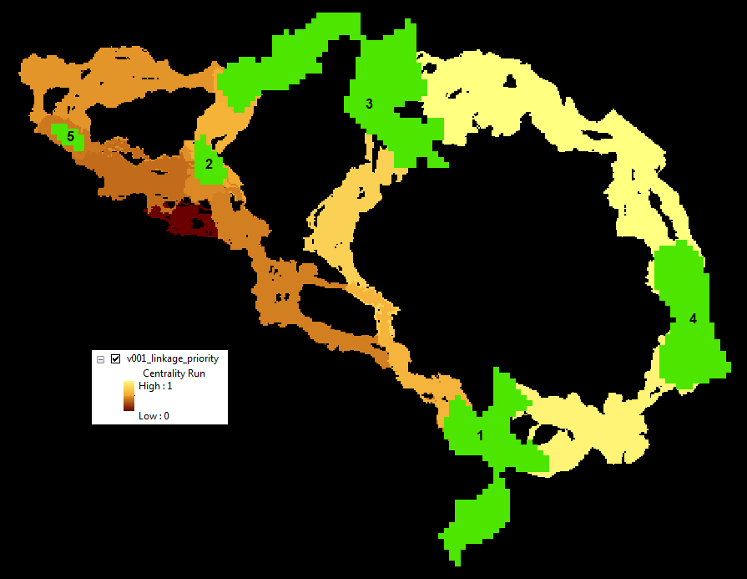

Note that Cores 2 and 3 are more central than Cores 1, 4 and 5. Hence, linkages that involve these cores have a higher relative priority than they did on the initial run with default parameters. Note, the Centrality Mapper Tool iterates through all core pairs. Pinchpoint Mapper was written after Centrality Mapper, and gives an “all-to-one” option which is faster on large landscapes and very similar in output.

## Inspect Core Area Value Component Calculations

The components of core area value are all calculated in the input Core Area Feature Class attribute table, as follows:

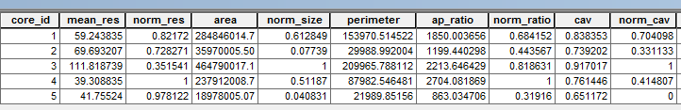

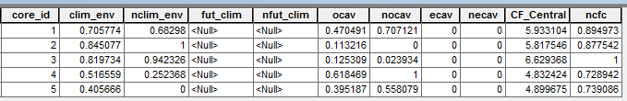

Note that the Expert Core Area Value (ecav) can be specified by editing this table. All other values will be overwritten on each run of LM/LP.

## Export Corridor Importance Value

Export Corridor Importance Value is a feature that allows you to enter in relative values for linkages based on expert opinion, or any other consideration, such as metapopulation dynamics, or a combination of the two. (When combining, these need to be combined in advance, and the resulting values are entered in here.)

1. This is evolving software with evolving authorship, but we have been advised to keep the original preferred citation for tracking purposes. John Gallo designed the changes from v2.0 to v3.0, and Darren Kavanagh wrote most of the new code.
2. from Joe Fargione, Brad McRae's supervisor